**Q1.**

**ANSWER-1.** 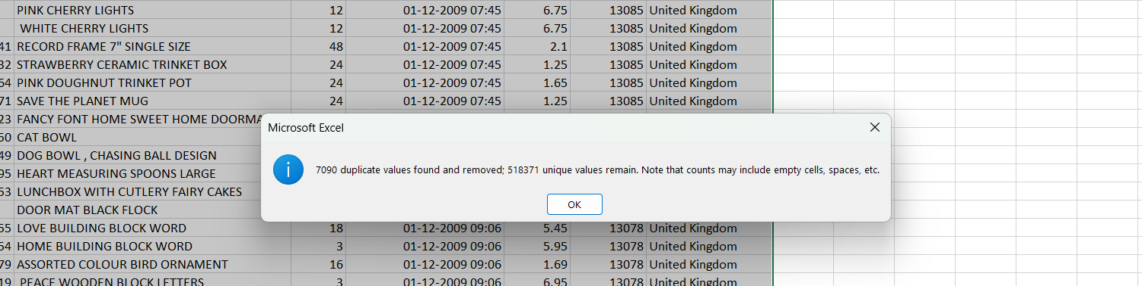

**EXPLANATION:**

1. Select the entire dataset.

2. Go to Data → Remove Duplicates.

3. In the popup, check all columns except InvoiceDate (as timestamps might vary slightly).

4. Click OK to remove duplicates.

**Q2.**

**ANSWER-2.**

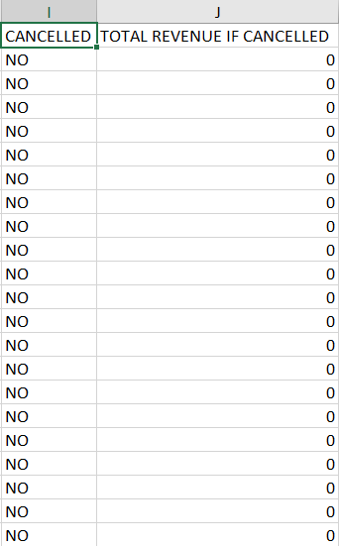 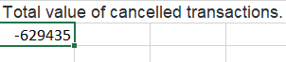

**EXPLANATION:**

1. Add a new column “Cancelled” and use:

=IF(LEFT(A2,1)="C", "Yes", "No")

2. Calculate Total Value of Cancellations:

Total Cancelled Sales = Quantity*UnitPrice

1. Insert a new column called “Cancelled Value” (e.g., Column I).

2. Use this formula in J2:

=IF(I2="Yes", D2*F2, 0)

3. Calculate the total cancelled amount:

=SUMIFS (J: J, A: A, "C*")

**Q3.**

**ANSWER-3.**

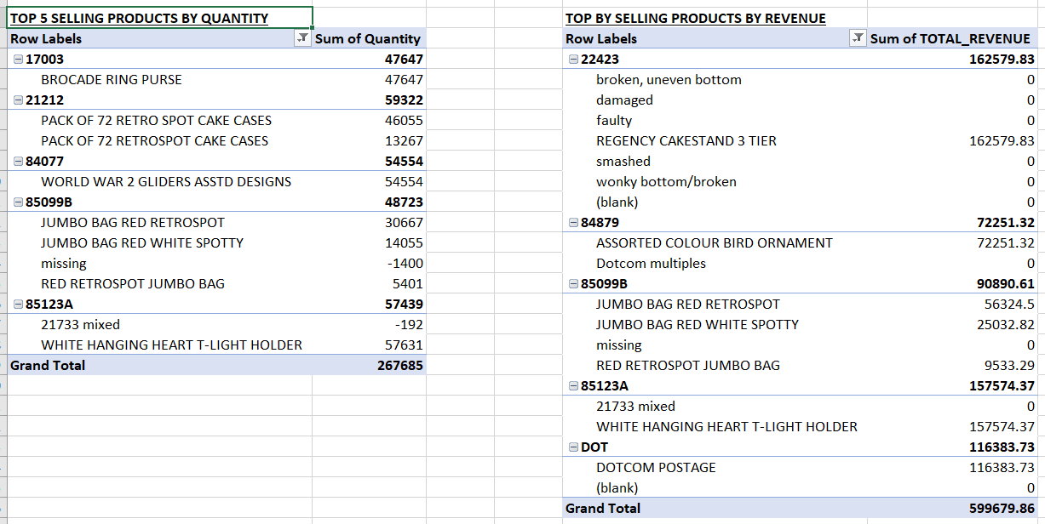

**EXPLANATION:**

By Quantity:

1. Use a Pivot Table:

• Drag Stock Code & Description to Rows.

• Drag Quantity to Values (set to Sum).

• Sort descending to get the Top 5.

By Revenue:

1. Create a new column:

=D2*E2

2. Use a Pivot Table:

• Drag StockCode & Description to Rows.

• Drag Total Revenue to Values (Sum).

• Sort descending.

**Q4.**

**ANSWER-4.**

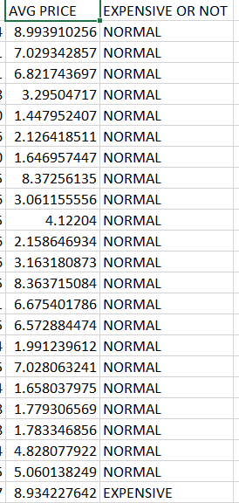

**EXPLANATION:**

1. Calculate Average Price per Item:

=AVERAGEIF(B:B, B2, E:E)

2. Flag expensive items:

=IF(E2>=PERCENTILE.INC(E:E, 0.9), "Expensive", "Normal")

**Q5.**

**ANSWER-5.**

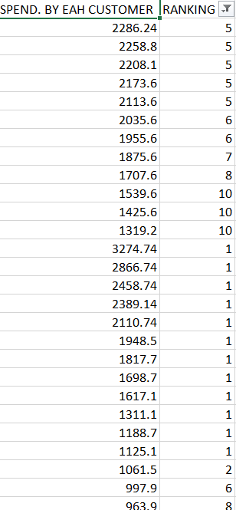

**EXPLANATION:**

1. Create Total Spending Per Customer:

=SUMIF(G:G, G2, K:K)

2. Use Ranking:

=RANK.EQ(N2, N:N, 0)

3. Filter Top 10.

**Q6.**

**ANSWER-6.**

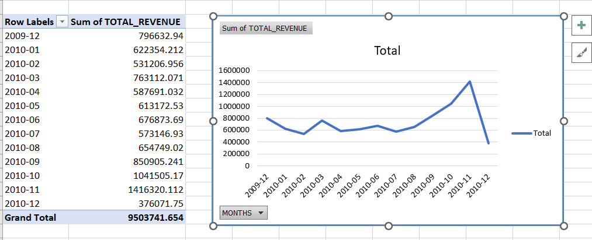

**EXPLANATION:**

1.Extract Month:

=TEXT(E2, "YYYY-MM")

2. Use a Pivot Table:

• Rows: Month

• Values: Total Revenue

3. Insert Line Chart.

**Q7.**

**ANSWER-7.**

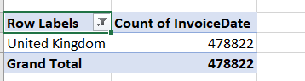

**EXPLANATION:**

1. Use a Pivot Table:

• Rows: Country

• Values: Count of InvoiceNo

2. Sort Descending to see the highest

**Q8.**

**ANSWER-8.**

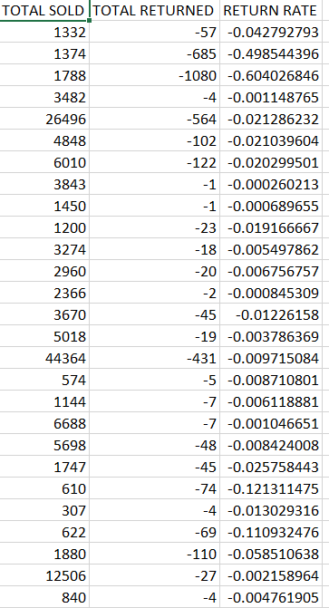

**EXPLANATION:**

1. Get Total Sold:

=SUMIFS(D:D, B:B, B2)

2. Get Total Returned:

=SUMIFS(D:D, B:B, B2, A:A, "C*")

3. Calculate Return Rate:

=Returned / Sold

**Q9.**

**ANSWER-9.**

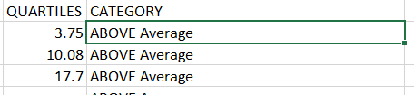

**EXPLANATION:**

1. Find the Quartiles using QUARTILE.INC

• Choose an empty cell

• Enter the following formulas:

=QUARTILE.INC(K:K, 1) // Q1 - Low sales products

=QUARTILE.INC(K:K, 2) // Q2 - Median sales

=QUARTILE.INC(K:K, 3) // Q3 - High sales

2. Categorizing Products into Quartiles

1. Create a new column (U) called “Category”.

2. Enter this formula in U2:

=IF(K2 <= $T$1, "Low Sales",

IF(K2 <= $T$2, "Below Average",

IF(K2 <= $T$3, "Above Average", "Top Sales")))

This classifies products based on their total sales quartile.

• Drag the formula down for all rows.

**Q10.**

**ANSWER-10.**

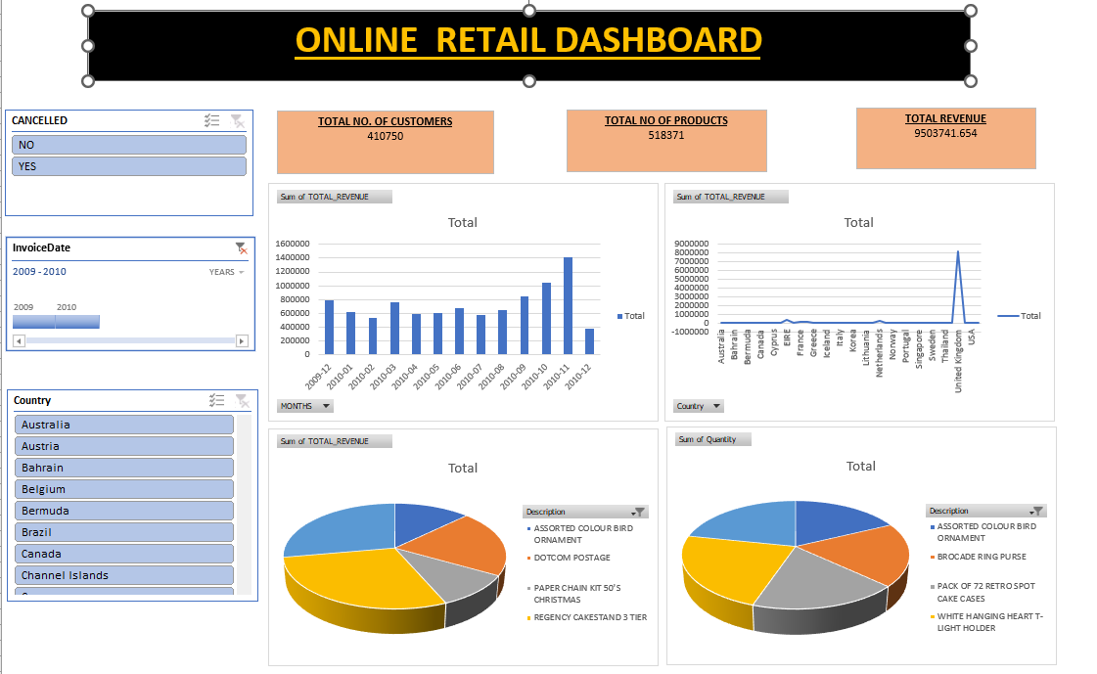

**EXPLANATION:**

1. Use Pivot Tables & Charts to display:

• Total Sales

• Average Sale per Transaction

• Top Products by Sales

• Sales by Country

2. Add Slicers for:

• Time Period

• Product Category

3. Arrange in a Dashboard Layout.

**VEDIO EXPLANATION OF ABOVE QUESTIONS:**

[**https://youtube.com/watch?v=5TLKTEIWaTE&feature=shared**](https://youtube.com/watch?v=5TLKTEIWaTE&feature=shared)